Diary 1. Steven Smith

Game premise: players moves around the board gathering different types of skills so they can improve their CV and win the interview.

Materials used: The game was a board game so it would’ve most likely used paper or card to make it.

Rules: Dice roll determines order people go in, landing on certain spaces will give you a skill card, you can’t have more than one of the same skill card, the game ends once someone lands on the interview over space, the player with the most skill cards at the end wins, you can see what other skills people can have so you can strategize around that.

How the game is played:

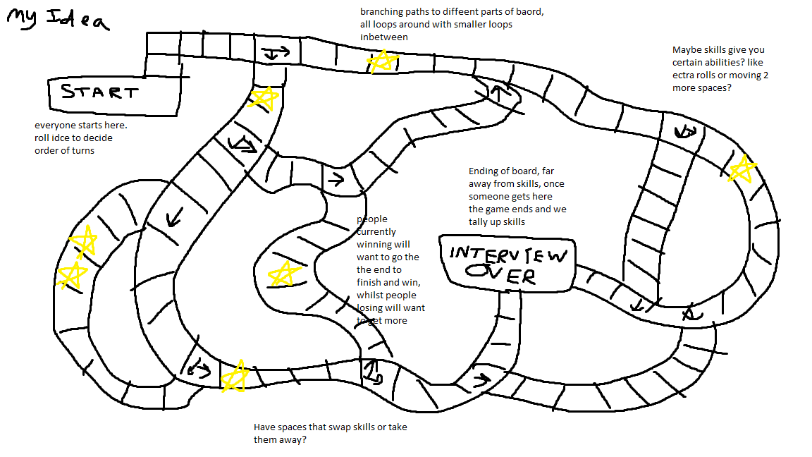

Above: concept art of the general idea and shape of the board, including notes on what I thought some cool ideas were.

The game starts off with a dice roll deciding the order which the players would go in, the players move around the board choosing different branching paths and directions and try to move towards the spaces that will give you skills. I placed the skills away from the ending space to prevent the chances of someone with insane luck winning as quick as possible, Players will try to strategize getting far ahead in the amount of skills they have. We later planned to have different spaces that could move you to different spaces on the board or take things away from you.

Play testing and game evolving: We spent a lot of the time exchanging ideas in the group chat so we didn’t have time to come up with a version of the game we were able to playtest.

Working in teams solving problems: since we were working on a group chat instead of talking in person trying to have a normal conversation was a lot slower and harder to do. Despite that everyone was still pitching ideas and listening to everyone else’s as well

Employability skills: The skills we used on the cards in game were: analysis skill, communication skill, teamwork skills, programming skills, communication skills, problem solving skills, creativity and time management. The importance of teamwork in these groups is to get used to working with different people and how ideas may change and evolve differently from what you imagined in your head

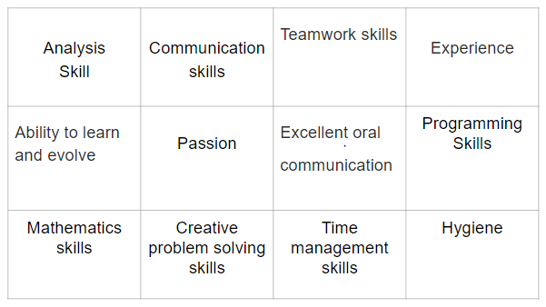

The types of skills employers want to see when developing games are: teamwork, so you know how to work with other people and let ideas evolve and change. Problem solving skills to think of ways to overcome coding problems and challenges. Programming is also something you should know as its what you will do mostly. In this session, we all suggested ideas in the group chat which is a good thing and the presentation went well too. If I had to improve something I would try and improve the time management and spend more time making and play testing instead of suggesting ideas.

Names: Steve Yap Hou Yuen, Rowan Noble, Will Connell, Josh Wye, Steven Smith, Giancarlo Trinidad